GUI Operating Systems

|  |
| --- |
| windows / user interface / iOS / experts / icons / desktop / user-friendly / Android  Graphical User Interface / Windows / menus / Linux / pointer / Macintosh |

The term user interface means the way the user interacts with a computer. With the first computers it was very difficult for users to access them. They had to memorize a lot of commands. Only experts used computers so they didn’t need a user-friendly interface.

In 1984, Apple made the __ Macintosh _, the first computer with a mouse and a Graphical User Interface (GUI). Macs made using the computer easy. A few years later, Microsoft made Windows, another easy to use GUI. A GUI uses a WIMP environment: Windows , icons , menus, and pointer. The background of the screen is called the desktop.

The most popular operating systems these days are Windows, iOS , Linux, MacOS, and Android.

Label the interface features on the screenshot of Apple’s MAC OS X:



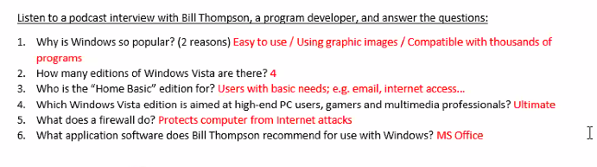



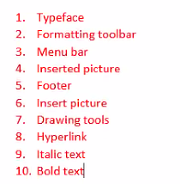

|  |
| --- |
| Language: Articles |

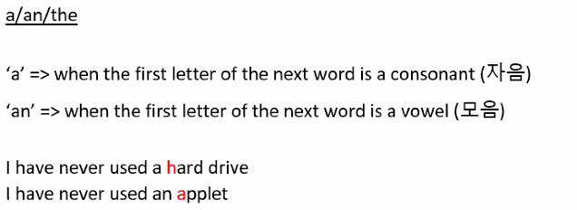

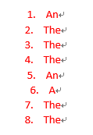

Word Processing

Label the features from Microsoft Word:

|  |
| --- |
| **bold text** / *italic text* / header / footer / inserted picture / menu bar / typeface /  hyperlink / standard toolbar / formatting toolbar / drawing tools / insert picture |



Complete the sentences:

The Standard _____________ lists icons to save or print a document, spell check, etc. The _______________ Toolbar is the area for changing font, alignment, indentation, etc.

A font has three elements: _____________, type style, and type size. For example, Times New Roman bold at 10 points.

Type style means what the typeface looks like; for example, B for _________, I for __________ and U for underline.

The __________ and ___________ commands put the same text at the top and bottom of every page.

Spreadsheets

Basic Vocabulary:

|  |  |
| --- | --- |
| 1. If we divide 8 by 2, we get C 2. If we subtract 2 from 8, we get B 3. If we multiply 8 by 2, we get D 4. The sum of 8 and 2 is A | 1. 8 + 2 = 2. 8 – 2 = 3. 8 / 2 = 4. 8 x 2 = |

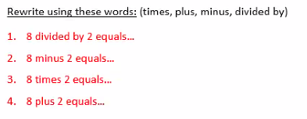



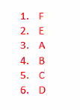

Listen to four employees and their problems with spreadsheets:

|  |  |
| --- | --- |
| **Action** | **Problem** |
| 1. |  |
| 2. |  |
| 3. |  |
| 4. |  |

